**Title:**

Tuberculosis on the rise in southern Mozambique (1997-2012)

**Authors:**

Alberto L. García-Basteiro, MD, MSc, Rafaela Moraes Ribeiro MD, MPH, Joe Brew BA, MA, MPH, Salomé Valencia MD, MPH, Helder Bulo BSc, Frank Cobelens MD, PhD, Eusebio Macete, MD PhD

**Affiliations:**

* Manhiça Health Research Center, Vila da Manhiça, Maputo, Mozambique; (A.L. García-Basteiro, RM Ribeiro, H Bulo, J Brew, E Macete)
* Barcelona Centre for International Health Research (CRESIB, Hospital Clínic-Universitat de Barcelona) Barcelona, Spain. (A.L. García-Basteiro, J Brew, S Valencia)
* Amsterdam Institute for Global Health and Development, Academic Medical Centre, Amsterdam, The Netherlands (A.L. Garcia-Basteiro, J Brew, F. Cobelens)

**Corresponding author**

Alberto L García-Basteiro

Email: [alberto.garcia-basteiro@manhica.net](mailto:alberto.garcia-basteiro@manhica.net)

Address: CP 1929 Maputo – Moçambique  
Tel.: (+258) 21 81 01 81 Ext 326 Tel. /Fax: (+ 258) 21 81 00 02

**Keywords**

Tuberculosis, HIV, incidence, epidemiology, Mozambique

**Running Title**

TB on the rise in Southern Mozambique (1997-2012)

**Word Count abstract:** 50

**Word Count text:**1193

**Abstract**

Using routine records from the TB National Tuberculosis Control Programme in the district of Manhiça, Mozambique…

**Introduction**

Tuberculosis (TB) remains an important public health concern and a leading cause of disease and death worldwide. Mozambique is one of the few high burden countries where incidence rates have not improved in recent years. The estimated TB incidence rate in 2014 was 552 cases per 100.000 population and the estimated case detection rate is very low, at just around 39%. The National Tuberculosis Control Program (NTP) in Mozambique was launched in 1977, and started to be applied on nationwide basis in 1985 (2)(3). The TB patient registration system began in 1984 and short course therapy followed in the late eighties (3)(4), even when the country was facing the adverse context of a civil war, with shortage of qualified medical staff, supplies and fragile deployment systems within the country. By 2000, the DOTS strategy (direct observed therapy, short-course therapy had complete coverage in all districts of Mozambique (4).

Up to date, very few studies on burden of disease assessment have been published in the country. Recent studies conducted at Manhiça district (Southern Mozambique) showed a high TB burden among children, people living with HIV, including high mortality. Analyzing the trends of tuberculosis as well as its characterization over time will contribute to better understand the current TB epidemic in Mozambique and inform public health policy. Thus, we evaluated how the TB incidence rates and other key TB indicators evolved from 1997 to 2012 in a high TB/HIV burden area of Southern Mozambique(6) (7).

**The study**

This retrospective descriptive study was conducted by the Manhiça Health Research Center (CISM from its acronym in Portuguese), located in the district of Manhiça, Southern Mozambique. All patients starting TB treatment in the period 1997-2012 were included.

During the study period, patients were registered in the two main health centers: Manhiça´s District Hospital and Xinavane Rural Hospital (located 52 kilometers apart from one another). There are also currently 12 peripheral health care centers, where treatment is supervised under a modified DOT (once weekly). The smear controls were done at the two main hospitals.

TB case definitions changed during the study period. In this analysis we adapted previous classifications to the updated 2014 WHO definitions (8). TB cases were classified as new, previously treated or unknown TB treatment history. Previously treated patient category includes: relapse (true relapse or reinfection), treatment after failure, treatment after lost to follow up and other previously treated patients. Following WHO definitions for incident cases, we considered all new cases and relapse cases as incident cases (9). Multi drug resistant tuberculosis (MDR-TB) began to be registered in 2011.

Diagnosis was based on smear microscopy (Ziehl Neelsen) following IUTLD smear grading scheme (10). Culture or Xpert MTB/RIF was not done routinely during the study period. Treatment outcomes patients were classified as cured, treatment completed, treatment failed, died, lost to follow up and not evaluated; treatment success was defined as the sum of “cured” and “treatment completed”.

Data from registry books were double entered into an electronic database and analysed using R (www.R-project.org). Our estimations for population at risk for each year between 1997 and 2007 were based on the annual demographic estimates of the National Institute of Statistics (INE) from Mozambique. From 2008 onwards, we applied CISM’s Demographic Surveillance System (DSS) growth rates to the previous population estimates. We grouped the entire study period into 4 year time bands, in order to minimize the effect of circumstantial situations (low human resources, heavy rains, etc.) which could affect some of the TB indicators. TB-HIV analysis was only possible since 2007 onwards, when HIV testing was fully implemented at the NTP offices.

CISM’s scientific and bioethical committees approved this research proposal (CIBS/070/2015). Formal permission to use official information contained in the books was granted by the Manhiça District Health Officer.

Over the 16 year period of the study, 8.985 cases of tuberculosis were registered in the district of Manhiça. The median age of TB patients was 33 (interquartile range: 24-45). The absolute number of cases was higher among men (55.9%) than women (44.1%).

The TB incidence rate increased nearly 3 fold from 1997 to 2012, for all age groups, from a annual incidence rate of 174 cases per 100,000 in 1997 to 573 incident cases per 100,000 at risk in 2012 **(Figure 1A)**. Those aged 40-44 had the highest incidence rate of all age groups (819 per 100,000 annually) (**Figure 2B**). Around 9.2% (878/8,495) were previously treated patients, without major variations in this proportion of across the years. Extrapulmonary TB (EPTB) accounted for 16.4% (1,477) of the cases.

From 2008 onwards the HIV status was recorded in more than 98% of registered incident TB patients **(Figure 1D).** The total number of incident TB cases with known HIV status was 4,986 (52.1%). Among these, 3,512 were HIV-infected (70,4%). From all the EPTB having any HIV status (843 cases), 641 cases (76.0%) were HIV-infected.

Around 83.0% of all registered pulmonary cases registered had a smear result. Of those, 62.3% had a smear positive result. The proportion of smear negative results increased during the study period, with 43.2% of pulmonary TB being smear negative in 2009-2012, a significant increase compared to the 16.8% negative rate during 1997-2000 (Pearson’s Chi-squared test with Yates’ continuity correction: p < 0.001). HIV infection was more frequent among smear negative cases (80.2%) than in smear positive (67.1%) (Pearson’s Chi-squared test with Yates’ continuity correction: p < 0.001).

The overall proportion of treatment success was 68.2% (6,534) while 15.4% (1,478) of patients died during TB treatment. Previously treated patients had significantly higher rates of being lost to follow up (p < 0.001) (see figure). Overall, women had a higher proportion of treatment success 70.8% of cases (2,966) compared to 66.2% (3,568) in men (p < 0.001). Similarly, women experienced fewer deaths during treatment: 14.8% (595 cases) compared to 17.0% (883), respectively (p = 0.003). The likelihood of being of being lost to follow up differed significantly by age, as well, with young people generally at greatest risk (p < 0.001) (see figure). Among patients with known HIV status and known treatment outcome, the likelihood of dying during treatment was significantly higher among those infected with HIV than those without (OR of 1.1, 95% confidence interval: 1.07-1.13).

**Conclusions**

**Biographical Sketch**

Dr Alberto L. García-Basteiro is a medical research fellow at Manhiça Health Research Center (CISM), Barcelona Institute for Global Health (ISGlobal) and Amsterdam Institute for Global Health ad Development (AIGHD). His current research interest is the epidemiology of tuberculosis and development of new tools to improve TB diagnosis and treatment. He coordinates different studies on the epidemiological characterization of tuberculosis in Southern Mozambique.

**References**

**Table 1.** Profile of adult TB patients (bacteriologically confirmed and clinically diagnosed) in the district of Manhiça (year 2011).

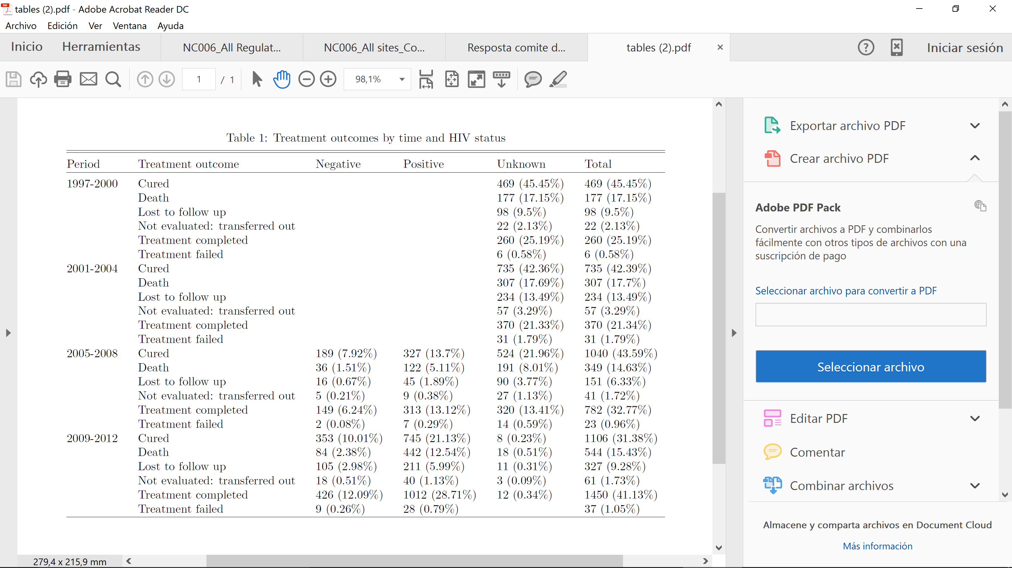

Figure 1

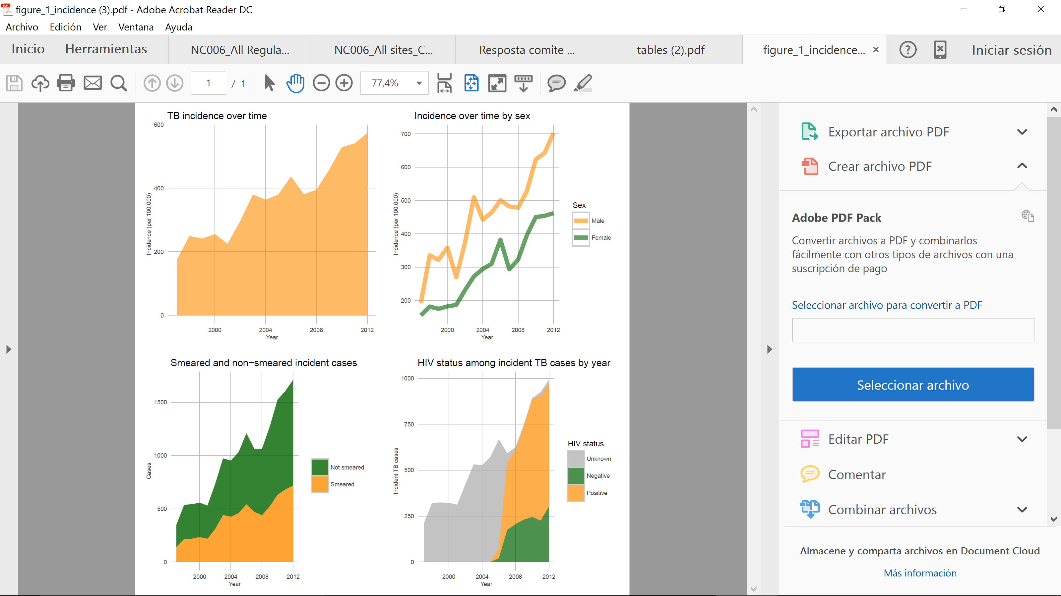

Figure 2

